Ingress network:

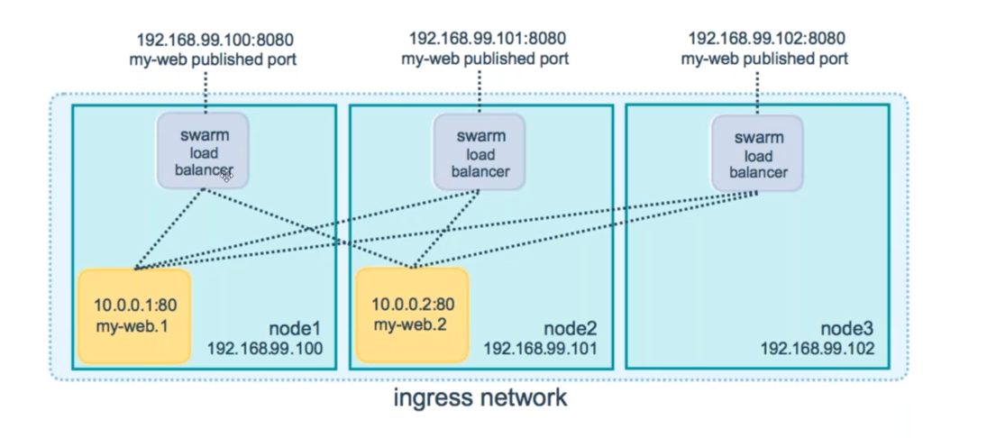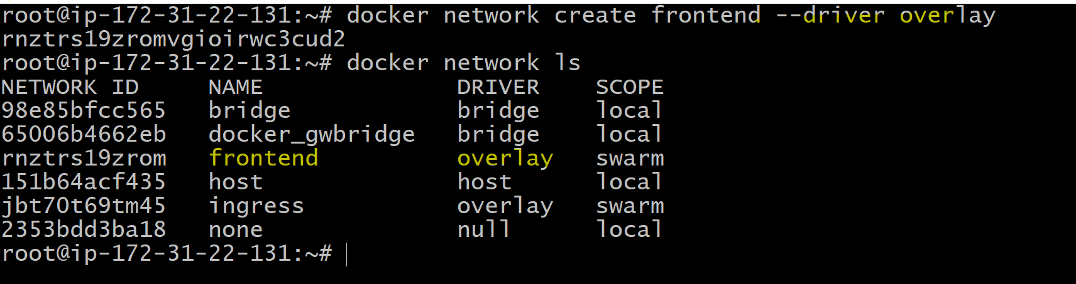

Ingress traffic:

First create 2 containers:

1. docker service create --name nginx001 --publish 80:80 viswkum/abcd:v1

2. docker service create --name nginx002 --publish 8081:80 viswkum/abcd:v2

3. docker service create --name nginx003 --publish 8082:80 viswkum/abcd:v3

publicIP:8081 it does not correct way to access.

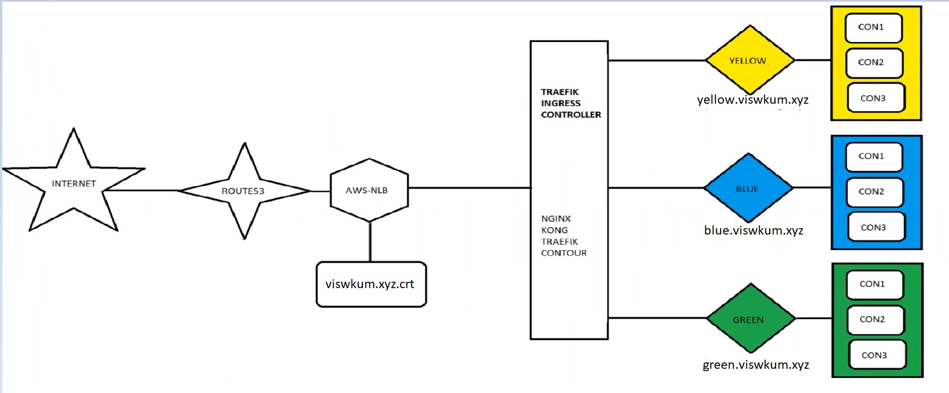

Step1: creating trafik network.

docker network create traefik-net --driver overlay



Step2: creating trafik controller

**TRAEFIK 1.6:**

docker service create \

    --name traefik16 \

    --constraint=node.role==manager \

    --publish 80:80 \

    --publish 9080:8080 \

    --mount type=bind,source=/var/run/docker.sock,target=/var/run/docker.sock \

    --network traefik-net \

    traefik:v1.6 \

    --docker \

    --docker.swarmmode \

    --docker.domain=traefik \

    --docker.watch \

    --web

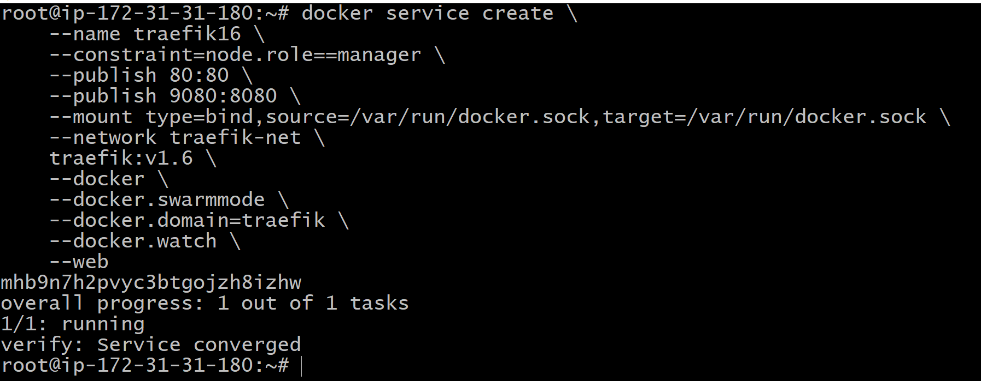

docker service scale traefik16=3

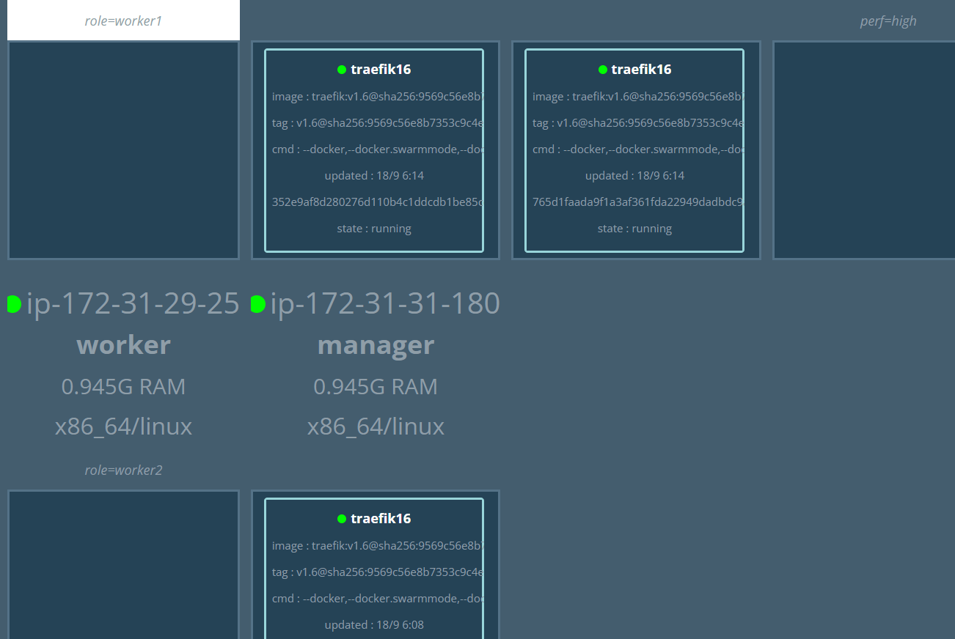

1. create NLB and add routes in route53

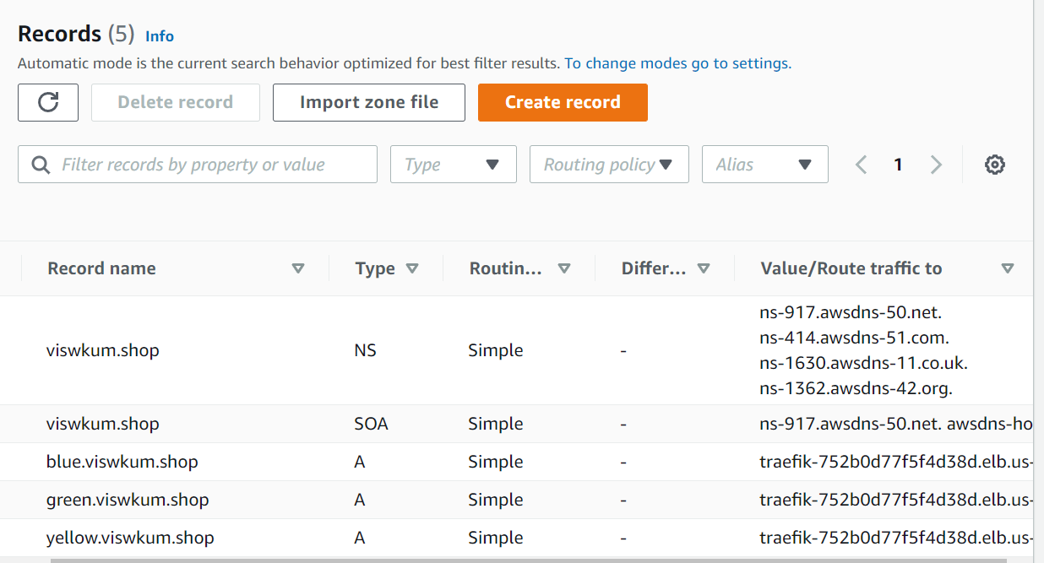

1. Create containers for yellow, blue and green
2. docker service create \
3. --name yellow \
4. --label traefik.port=80 \
5. --network traefik-net \
6. --label traefik.frontend.rule=Host:yellow.kumarixyz.shop \
7. viswkum/abcd:v1
8. ####################################################
9. docker service create \
10. --name blue \
11. --label traefik.port=80 \
12. --network traefik-net \
13. --label traefik.frontend.rule=Host:blue.kumarixyz.shop \
14. viswkum/abcd:v2
15. ##################################################
16. docker service create \
17. --name green \
18. --label traefik.port=80 \
19. --network traefik-net \
20. --label traefik.frontend.rule=Host:green.kumarixyz.shop \
21. nginx:latest

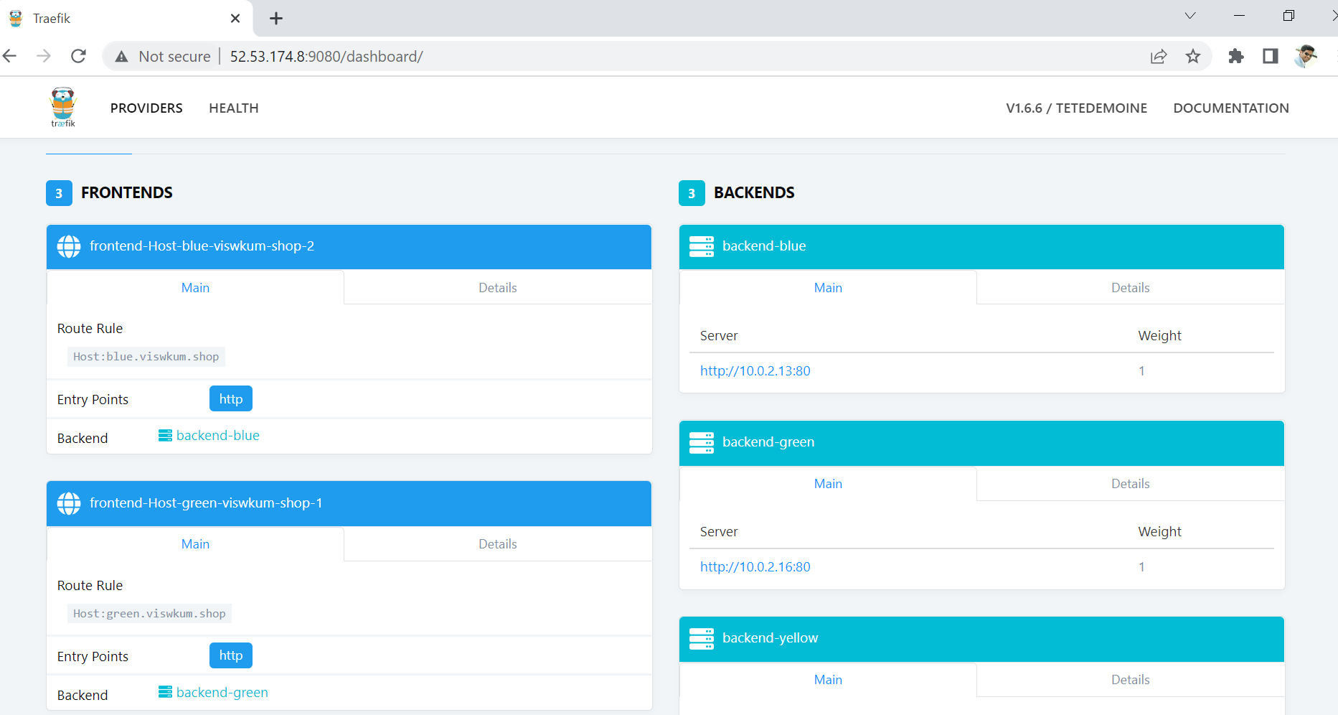

Now will scale the containers to 3 for all websites.

docker service scale yellow=3

docker service scale blue=3

docker service scale green=3

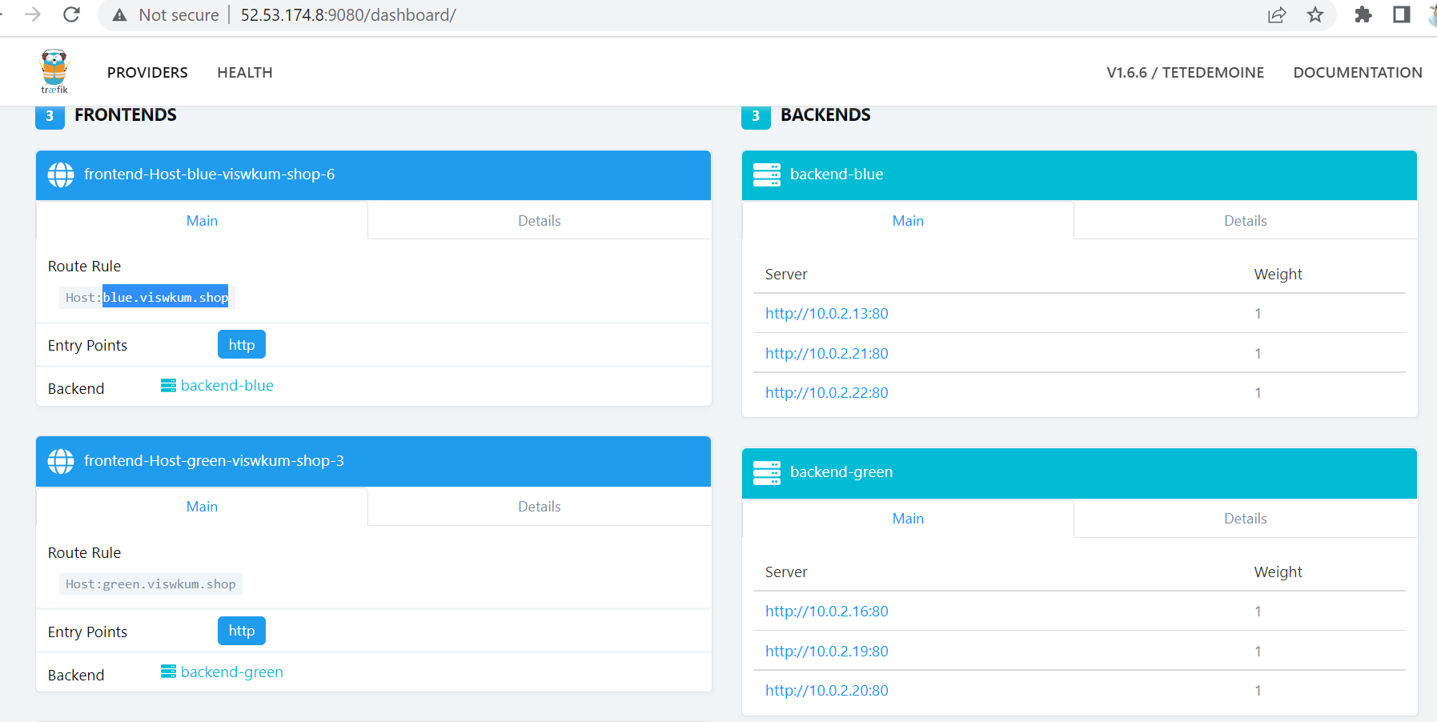

1. Docker service ls
2. docker service inspect a3woorv4f8qf(container ID of yellow)

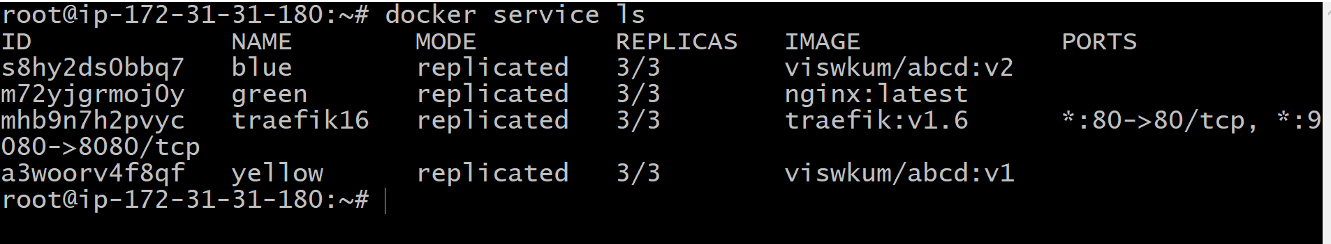

1. Now we have to validate the websites.

Yellow.kumarixyz.shop

Blue.kumarixyz.shop

Green.kumarixyz.shop

####################################

##All steps:

docker network create traefik-net --driver overlay

#####################

docker service create \

    --name traefik16 \

    --constraint=node.role==manager \

    --publish 80:80 \

    --publish 9080:8080 \

    --mount type=bind,source=/var/run/docker.sock,target=/var/run/docker.sock \

    --network traefik-net \

    traefik:v1.6 \

    --docker \

    --docker.swarmmode \

    --docker.domain=traefik \

    --docker.watch \

    --web

########################################

docker service scale traefik16=3

#############################################

docker service create \

    --name yellow \

    --label traefik.port=80 \

    --network traefik-net \

    --label traefik.frontend.rule=Host:yellow.kumarixyz.shop \

    viswkum/abcd:v1

####################################################

docker service create \

    --name blue \

    --label traefik.port=80 \

    --network traefik-net \

    --label traefik.frontend.rule=Host:blue.kumarixyz.shop \

    viswkum/abcd:v2

##################################################

docker service create \

    --name green \

    --label traefik.port=80 \

    --network traefik-net \

    --label traefik.frontend.rule=Host:green.kumarixyz.shop \

    nginx:latest

###############

docker service scale yello=3

docker service scale blue=3

docker service scale green=3